**Exercise 2**

**Mariyum Bashir**

(A).

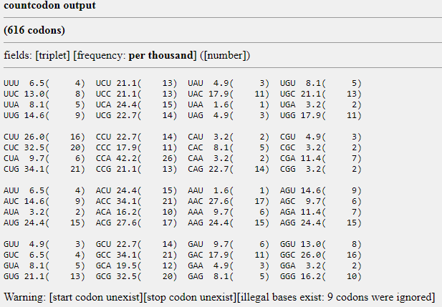

(B).





©.

CLUSTAL O(1.2.4) multiple sequence alignment

NP_064362.1 MSFGRDMELEHFDERDKAQRYSRGSRVNGLPSPTHSAHCSFYRTRTLQTLSSEKKAKKVR 60

NP_001182468.1 ------------------------------------------------------------ 0

NP_001104521.1 ------------------------------------------------------------ 0

NP_064362.1 FYRNGDRYFKGIVYAISPDRFRSFEALLADLTRTLSDNVNLPQGVRTIYTIDGLKKISSL 120

NP_001182468.1 ------------------------------------------------------------ 0

NP_001104521.1 ------------------------------------------------------------ 0

NP_064362.1 DQLVEGESYVCGSIEPFKKLEYTKNVNPNWSVNVKTTSASRAVSSLATAKGGPSEVRENK 180

NP_001182468.1 ------------------------------------------------------------ 0

NP_001104521.1 ------------------------------------------------------------ 0

NP_064362.1 DFIRPKLVTIIRSGVKPRKAVRILLNKKTAHSFEQVLTDITDAIKLDSGVVKRLYTLDGK 240

NP_001182468.1 ------------------------------------------------------------ 0

NP_001104521.1 ------------------------------------------------------------ 0

NP_064362.1 QVMCLQDFFGDDDIFIACGPEKFRYQDDFLLDESECRVVKSTSYTKIASASRRGTTKSPG 300

NP_001182468.1 ------------------------------------------------------------ 0

NP_001104521.1 ------------------------------------------------------------ 0

NP_064362.1 PSRRSKSPASTSSVNGTPGSQLSTPRSGKSPSPSPTSPGSLRKQRISQHGGSSTSLSSTK 360

NP_001182468.1 -------MLELIEVNGTPGSQLSTPRSGKSPSPSPTSPGSLRKQRISQHGGSSTSLSSTK 53

NP_001104521.1 -------MLELIEVNGTPGSQLSTPRSGKSPSPSPTSPGSLRKQRISQHGGSSTSLSSTK 53

. .***********************************************

NP_064362.1 VCSSMDENDGPGEGDELGRRHSLQRGWRREESEEGFQIPATITERYKVGRTIGDGNFAVV 420

NP_001182468.1 VCSSMDENDGPGEGDELGRRHSLQRGWRREESEEGFQIPATITERYKVGRTIGDGNFAVV 113

NP_001104521.1 VCSSMDENDGPGE----------------EESEEGFQIPATITERYKVGRTIGDGNFAVV 97

************* *******************************

NP_064362.1 KECIERSTAREYALKIIKKSKCRGKEHMIQNEVSILRRVKHPNIVLLIEEMDVPTELYLV 480

NP_001182468.1 KECIERSTAREYALKIIKKSKCRGKEHMIQNEVSILRRVKHPNIVLLIEEMDVPTELYLV 173

NP_001104521.1 KECIERSTAREYALKIIKKSKCRGKEHMIQNEVSILRRVKHPNIVLLIEEMDVPTELYLV 157

************************************************************

NP_064362.1 MELVKGGDLFDAITSTSKYTERDASGMLYNLASAIKYLHSLNIVHRDIKPENLLVYEHQD 540

NP_001182468.1 MELVKGGDLFDAITSTSKYTERDASGMLYNLASAIKYLHSLNIVHRDIKPENLLVYEHQD 233

NP_001104521.1 MELVKGGDLFDAITSTSKYTERDASGMLYNLASAIKYLHSLNIVHRDIKPENLLVYEHQD 217

************************************************************

NP_064362.1 GSKSLKLGDFGLATIVDGPLYTVCGTPTYVAPEIIAETGYGLKVDIWAAGVITYILLCGF 600

NP_001182468.1 GSKSLKLGDFGLATIVDGPLYTVCGTPTYVAPEIIAETGYGLKVDIWAAGVITYILLCGF 293

NP_001104521.1 GSKSLKLGDFGLATIVDGPLYTVCGTPTYVAPEIIAETGYGLKVDIWAAGVITYILLCGF 277

************************************************************

NP_064362.1 PPFRGSGDDQEVLFDQILMGQVDFPSPYWDNVSDSAKELINMMLLVNVDQRFSAVQVLEH 660

NP_001182468.1 PPFRGSGDDQEVLFDQILMGQVDFPSPYWDNVSDSAKELINMMLLVNVDQRFSAVQVLEH 353

NP_001104521.1 PPFRGSGDDQEVLFDQILMGQVDFPSPYWDNVSDSAKELINMMLLVNVDQRFSAVQVLEH 337

************************************************************

NP_064362.1 PWVNDDGLPENEHQLSVAGKIKKHFNTGPKPSSTAAGVSVIATTALDKERQVFRRRRNQD 720

NP_001182468.1 PWVNDDGLPENEHQLSVAGKIKKHFNTGPKPSSTAAGVSVIATTALDKERQVFRRRRNQD 413

NP_001104521.1 PWVNDDGLPENEHQLSVAGKIKKHFNTGPKPSSTAAGVSVIATTALDKERQVFRRRRNQD 397

************************************************************

NP_064362.1 VRSRYKAQPAPPELNSESEDYSPSSSETVRSPNSPF 756

NP_001182468.1 VRSRYKAQPAPPELNSESEDYSPSSSETVRSPNSPF 449

NP_001104521.1 VRSRYKAQPAPPELNSESEDYSPSSSETVRSPNSPF 433

************************************

